LineageIQ Platform — Architecture Guardrails & Best Practices
1. Executive recommendation
LineageIQ should be designed as an enterprise-grade, AI-assisted metadata intelligence platform, not simply an AI application that scans code and generates lineage.
The platform should support end-to-end lineage discovery, transformation intelligence, data quality (DQ) controls, impact analysis, regulatory traceability, and enterprise metadata governance.
The architecture should follow five fundamental principles:
- Metadata-first, AI-assisted: Deterministic parsing and authoritative metadata take precedence over AI inference.
- Standards-based interoperability: Use OpenLineage-compatible events and a canonical enterprise metadata model.
- Evidence-driven intelligence: Every lineage relationship and DQ assertion must be traceable to its supporting evidence.
- Security and governance by design: Enforce least privilege, sensitive-data controls, tenant isolation, and auditable access.
- Human-governed autonomy: AI agents may discover, infer, and recommend lineage, but should not independently publish uncertain relationships as authoritative.
2. Recommended reference architecture

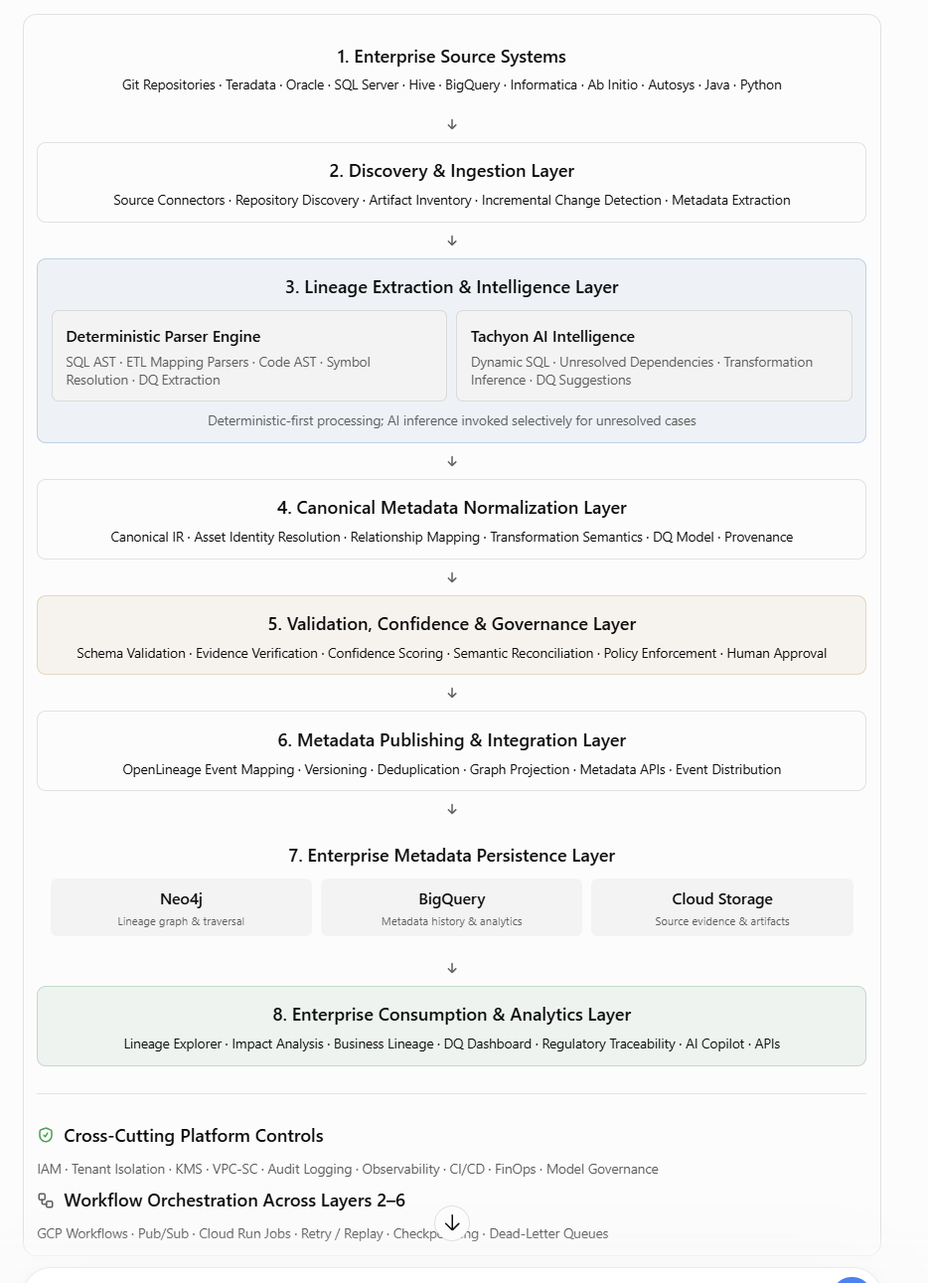

3. Enterprise architecture guardrails
The following guardrails should become mandatory architecture review requirements.

ID | Architecture guardrail | Enforcement
ARC-01 | Separate metadata extraction from AI inference | Mandatory
ARC-02 | Use a canonical enterprise metadata model | Mandatory
ARC-03 | Support OpenLineage-compatible event ingestion and export | Mandatory
ARC-04 | Preserve source evidence for every lineage edge | Mandatory
ARC-05 | Never publish unverified AI-inferred lineage as authoritative | Mandatory
ARC-06 | Maintain versioned metadata and historical lineage | Mandatory
ARC-07 | Support system, dataset, and element-level lineage | Mandatory
ARC-08 | Represent DQ rules separately from DQ execution results | Mandatory
ARC-09 | Use asynchronous, independently scalable processing services | Mandatory
ARC-10 | Enforce source-system access boundaries and tenant isolation | Mandatory
ARC-11 | Use approved, versioned AI models and prompts | Mandatory
ARC-12 | Enforce operational quotas, retry limits, and cost budgets | Mandatory
ARC-13 | Support human review and correction of inferred lineage | Mandatory
ARC-14 | Expose metadata through governed, versioned APIs | Mandatory
ARC-15 | Maintain complete audit trails for metadata changes | Mandatory

4. AI agent architecture guardrails
The Tachyon-based custom LLM agents should operate as bounded, specialized components.
Agent | Responsibility | Guardrail
Discovery Agent | Discover repositories, applications, and metadata assets | Only scan authorized repositories and paths
Parser Agent | Extract SQL, AST, configuration, and code dependencies | Deterministic extraction first
Inference Agent | Resolve dynamic SQL, embedded variables, indirect dependencies | Must identify evidence and uncertainty
Reconciliation Agent | Match extracted assets with enterprise catalog identities | No unverified entity merges
DQ Intelligence Agent | Identify and classify DQ checks | Distinguish observed rules from suggested rules
Validation Agent | Verify lineage against metadata and runtime evidence | Independent of inference agent
Publishing Agent | Publish approved metadata | Policy-gated write access only

Mandatory AI controls
- Agents must not have unrestricted repository or database access.
- Source code, comments, and retrieved documents must be treated as untrusted inputs, not executable instructions.
- Agent tool calls must use allowlisted capabilities and least-privilege identities.
- AI output must pass schema validation, entity resolution, evidence validation, and policy checks.
- Prompt version, model version, input artifact version, and execution ID must be recorded.
- Agent loops must have maximum iteration, token, timeout, and cost limits.
- Inference failures must not block deterministic lineage extraction.
Recommendation: Use a workflow orchestrator to control the agent lifecycle rather than allowing autonomous agents to invoke each other without boundaries.

5. Lineage extraction and confidence guardrails
Recommended lineage publication lifecycle
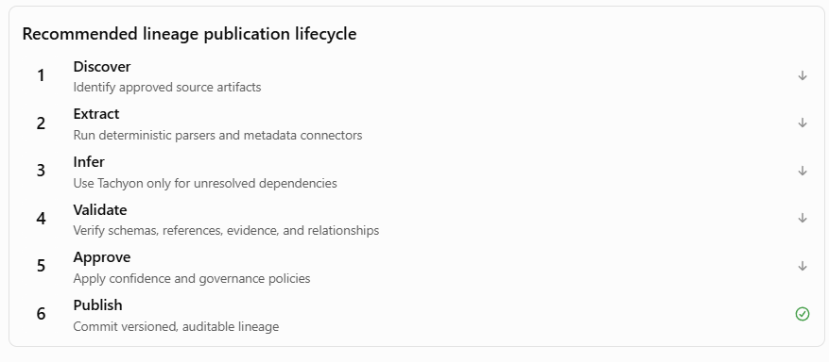

Suggested confidence policy
These thresholds are proposed initial policies, not industry standards. Calibrate them against a labeled validation dataset.
Confidence | Treatment
95–100% | Eligible for automatic publication only with strong, independently validated evidence
80–94% | Publish as provisional or route for review
60–79% | Human validation required
Below 60% | Quarantine; do not expose as trusted lineage

Confidence should not be calculated from LLM self-reported certainty alone. Use evidence quality, parser results, schema compatibility, runtime corroboration, and prior validation outcomes.
A deterministic parser result can still be incorrect if it uses stale code, unresolved macros, or incomplete environment context.

6. Canonical metadata model guardrails
Use OpenLineage as the interoperability foundation, extended with LineageIQ-specific metadata.
OpenLineage supports lineage relationships and DQ assertion results, including field-level relationships and dataset or column-level checks.

Entity | Required attributes
System | System ID, platform, environment, owner
Application | Application ID, repository, business domain
Process / Job | Job ID, execution engine, schedule
Dataset | Qualified name, schema, owner, classification
Data Element | Column name, type, classification
Transformation | Expression, mapping, source reference
Lineage Edge | Source, target, transformation, confidence, evidence
DQ Rule | Rule ID, scope, expression, severity, version
DQ Execution | Run ID, result, actual/expected, timestamp
Evidence | Artifact URI, commit SHA, location, hash
Approval | Reviewer, decision, timestamp, reason

Additional requirements:
- Use globally unique, stable asset identities.
- Separate logical assets from physical implementations.
- Maintain valid-time and observation-time history.
- Preserve multiple conflicting lineage assertions rather than silently overwriting them.
- Define explicit transformation semantics such as direct, derived, aggregation, filtering, and conditional.
- Keep business lineage separate from technical lineage while supporting mappings between them.

7. Data quality architecture guardrails
DQ should be modeled as a first-class capability, not merely as annotations on lineage relationships.
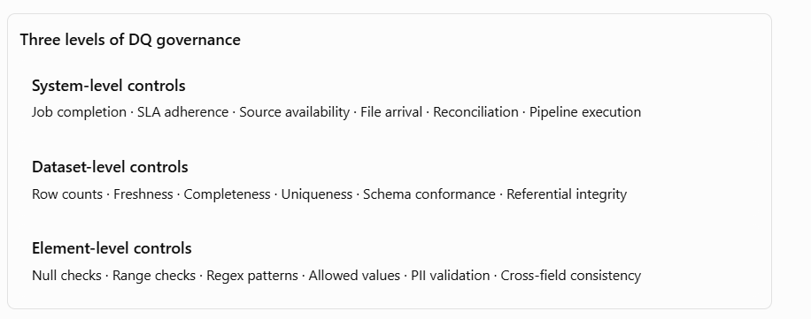

DQ-specific requirements
- Every DQ rule must have an owner, scope, version, severity, and enforcement policy.
- Distinguish extracted, inferred, and recommended DQ rules.
- Store rule definitions separately from execution history.
- Capture DQ failures as events linked to impacted datasets and processes.
- Support propagation of DQ impact through downstream lineage.
- Prevent AI-generated DQ recommendations from becoming enforced production controls without approval.
- Record the data snapshot, evaluation time, and rule version for reproducibility.
Use standard OpenLineage DQ facets where they fit; define custom, versioned extensions for richer system-level controls and rule governance.

8. GCP deployment and infrastructure guardrails
Area | Recommended implementation | Guardrail
Agent runtime | GKE | Stateless workers; bounded execution
Workflow orchestration | Workflows | Durable, explicit state transitions
Asynchronous messaging | Pub/Sub | Idempotent consumers, DLQ
Metadata analytics | BigQuery | Partitioning, clustering, access policies
Graph processing | BigQuery / Spanner ?? | Controlled traversal and query limits
Evidence storage | Cloud Storage | Encryption, retention, versioning
Secrets | Secret Manager | No embedded credentials
Identity | IAM / Workload Identity | Dedicated service identities
Network | Private connectivity / VPC-SC where supported | Restrict data exfiltration
Encryption | Cloud KMS | Enterprise-managed keys where required
Monitoring | Cloud Monitoring / Logging | Centralized observability
CI/CD | Cloud Build / Artifact Registry | Scanned and approved artifacts
These align with Google's security-by-design, reliability, operational excellence, and cost-optimization guidance.

For Tachyon agents, choose Cloud Run when the runtime supports its container and resource constraints. Use GKE or an approved accelerator-capable runtime if the model requires specialized GPU, persistent serving, or scheduling capabilities unavailable in the chosen Cloud Run configuration.

9. Security, privacy, and regulatory controls
For a financial-services enterprise, the platform must treat lineage metadata as potentially sensitive information.
Mandatory controls:
- Source code and extracted SQL must remain within approved security boundaries.
- Credentials, secrets, PAN, and unnecessary PII must be removed or masked before model processing.
- AI model endpoints must be approved for the relevant data classification.
- Enforce repository-level, system-level, and dataset-level authorization.
- Apply authorization to graph traversal results, not just API entry points.
- Prevent cross-tenant metadata leakage.
- Record user and agent actions in immutable or tamper-evident audit logs.
- Establish retention and deletion policies for source artifacts, prompts, responses, and evidence.
- Require formal approvals for sensitive regulatory lineage changes.
For CCAR, FR Y-14, and other critical reporting use cases, require reproducible lineage snapshots tied to the applicable reporting period.

10. Reliability, performance, and cost guardrails
Dimension | Best practice | Proposed initial target
Availability | Multi-zone managed services where supported | 99.9% platform API
Ingestion | Idempotency and replay support | No silent event loss
Parsing | Parallel processing by repository or artifact | Configurable concurrency
AI inference | Invoke only for unresolved cases | Track AI invocation rate
Graph queries | Pagination, depth limits, query timeouts | P95 under 3 seconds for common queries
Recovery | Checkpointing and resumable scans | Retry without full rescan
Metadata freshness | Incremental updates and change detection | Under 24 hours for scheduled sources
Cost | Per-tenant, per-source, per-agent budgets | Alert at 80% of budget

These are suggested service-level objectives to validate through load testing, not guaranteed platform performance.
Use incremental scanning based on Git commit hashes, artifact fingerprints, and schema versions. Avoid reprocessing unchanged assets.

